CSA0501-DATABASE MANAGEMENT SYSTEMS
LAB EXPERIMENTS DATE: 17-08-2026

EXPERIMENT 11 - To create and use an AUTO_INCREMENT sequence for the InternID column in the INTERN table.

AIM:

To create and use an AUTO_INCREMENT sequence for the InternID column in the INTERN table.

PROCEDURE:

Modify the existing INTERN table to make InternID auto-increment.

Insert intern records without specifying InternID.

Display the automatically generated IDs.

Insert a record with a manually specified InternID.

Remove the AUTO_INCREMENT property.

PROGRAM:

1. Apply AUTO_INCREMENT to InternID
ALTER TABLE INTERN
MODIFY InternID INT AUTO_INCREMENT;

SELECT * FROM INTERN;
OUTPUT:
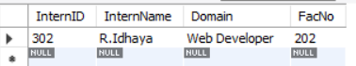

2. Manually populate InternID
INSERT INTO INTERN
(InternID, InternName, Domain, Age, Email, FacNo)
VALUES
(400, 'Arun', 'Cyber Security', 22, 'arun@gmail.com', 203);

SELECT * FROM INTERN;
OUTPUT:
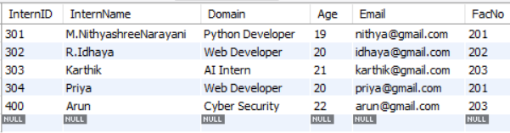

3. Drop AUTO_INCREMENT
ALTER TABLE INTERN
MODIFY InternID INT;
SELECT * FROM INTERN;

OUTPUT:
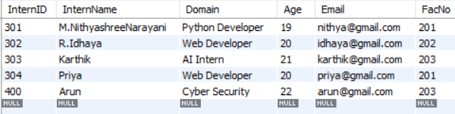

RESULT:
Thus, the AUTO_INCREMENT sequence was successfully applied to the InternID column of the INTERN table. Records were inserted using automatically generated and manually assigned IDs, and the AUTO_INCREMENT property was successfully removed.

